Our October Visit to the Hedges - October 2017

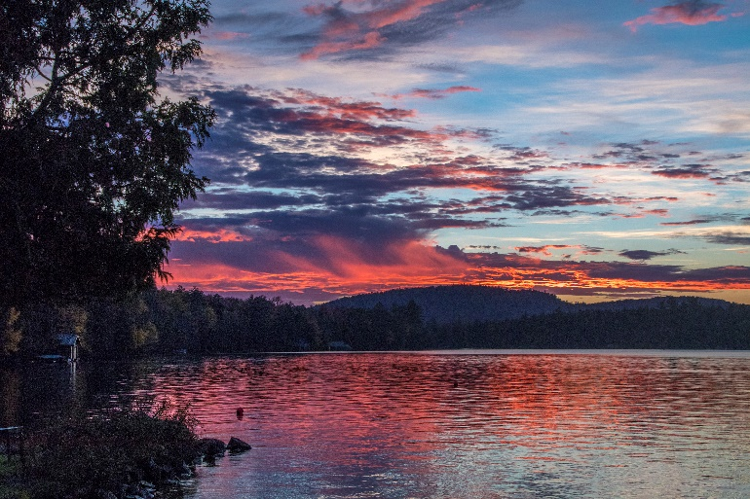We visited the Hedges on Blue Mountain Lake, NY this October and enjoyed an interesting variety of weather. October is always a beautiful time to experience the beauty of the NYS wilderness. During our week there, we enjoyed the superb hospitality of the Hedges staff and excellent cooking while hiking and kayaking in a variety of weather. Several water runs expanded our fond memories of paddling in the rain and another fine tuned our skills of paddling long distances in very strong on-coming winds. An excellent week!

And for the photos, click [The Hedges – October 2017](https://photos.app.goo.gl/PRZC8MCqDth038mJ3).